UNO Manual

:-=+*****************************************************************************************=-:.
.-=***************************************************************************************************=:
.=**************************************************************************************************###%**+:
-********************************************************************************************+=-+*#%*%#%##***+.
.=****************************************************************************************+=:.:-+::**%**#********:
+*************************************************************************************+:.:-+**+--# =**************:
=*************************************************************************************-.+%+-:.:::.+=.+**************.
:************************************************************************************=.-#%##.::::::.#::**************+
+***********************************************************************************= *%#**#=.::::::-# =**************=
************************************************************************+=-::....::-=.=%****%:::::::.+=.***************
*********************************************************************+-.:=+***++***+=. *#*#%%#.::::::.#:-**************
*******************************************************************=.:+*+-...::::...-+*+%%%#*%+.::::::-# +*************
*****************************************************************-.-#+:.::::::::::::::.-#%*#%%%-::::::.*=.*************
*******************************************************+=:..-**=.-#*::::::::::..::::::::.-%%%%%#.:::::::%.-************
**************************************************+=-:.-+*** =:.*@+.:::::::-+*##*+-.::::::.*%%%%+.:::::.=* +***********
************************************************+-.=**+=:..#- -%@+.::::::*@@@@@@@@@#-.:::::.*%%%%-::::::.#=.***********
***********************************************=.=%#%.::::::%=@@%.::::::%@@@@@@@@#**%*.:::::.#%%%#.:::::::%.-**********
************************************+=-::=****.:##**#+.::::.=@@@+.::::.%*:...:+%#****%*.:::::-@%%%*.:::::.=* +*********
********************************=-:.:=***-.-+*-.%****@-:::::.#@@-::::::% -***+-.+%**%%%-:::::.%%%%%-.::..-=%-.*********
***************************+=:.:-+**=-..:=*+::=.=%*#%%%.::::::@@-::::::% =*****+.=%@#*%*.::::.*%%%%%-=+**=-:#.-********
***********************+-:.-+**=%@=.::::::.:+*=. #%@#*%+.::::.=@=.::::.#-.******+ *##%@#.::::.*%%%%%%=:..::.=* +*******
*********************+:.*%+=:.::-@%.:::::::::.-**=@*#%@@::::::.##.::::::%.-******::@@@@+.::::.#%%%%%%=.:::::.#-:*******
*************+=*****-.+%*%=.::::.+@*.::::::::::.:=#@@@@@%.::::::@-:::::.-#.:+****-.@@@%.:::::.%*%%%%%%:::..:-*# =******
********+=-:.-:.***-.%#***%::::::.%@-.::::::::::::.:+%@@@+.::::.+%.:::::.:#+.:---.=@@*.:::::.*=.%%%%%%*:=*#%%+.-*******
*****-:.:=**+=%.-**+ +%***%#.:::::-@%.:::::.:.:::::::.-*@@::::::.#%:::::::.-+**+***=:.:::::.=# .=%%%%%%%%%%#::+********
***=.-#%=:..:.=* +**- %##@%%=.::::.*@*.::::.=#=:.::::::.:=*.::::::@%-.:::::::.....::::::::.+#.-+ *%%%%%#*=:.=**********
*+::#@@@::::::.#-.***::@%#*%%::::::.%@-.::::.#@@*-.:::::::...::::.+@@*:.::::::::::::::::.-%+.=**-.%*+-::-=*************
*.:@@@@@%.::::::%.-**+ +%#@@@*.:::::-@%.::::::%@@@%+:.::::::::::::.%@@@#=:.::::::::::.:+%%-.+****..-=+*****************
*= #@@@@@+.::::.+* +**-.%@@@@@=.::::.*@*.::::.=@@@@@@#=.::::::::::::@@@@@@#+=-----=+*%@@+.-****************************
**:.@@@@@@::::::.#-.***.-@@@@@%.:::::.%@-:::::.#@@@@@@@@*-.::::::::.+@@@@@@@@@@@@@@@@%+.:+*****************************
**+.=@@@@@#.::::::%.-**+ *@@@@@*.::::.=@%.::::::@@@@@@@@@@%+:.::::::.%@@@@@@@@@@@@#+-.-+*******************************
***= #@@@@%+.::::.++ +**-.%@@@@@-:::::.%@+.::::.=#=#@@@@@@@@@#=...:-+#*:-=++++=-:.:-+**********************************
****::@@%**%::::::.%:.***.-@@@@@*.::::.*@@-:::::.#- :+%@@@@@@@@%*%@@%=.-+======++**************************************
****+.+%***##.:::::-%.-**+ *@@@@*.::::.+@@%.::::::%.:-.-*@@@@@@@@@%+.:+************************************************
*****= ##**%@=.::::.=*.-+*::@@@@::::::.*@@@+.::::.=* +*=:.=#@@#+-:.-+**************************************************
******::%#@#*%::::::.-#=:..-@@*:::::::.%@@@@::..-=*@::****=...:-+******************************************************
******+ +@**%@%.::::::.-++++=:.::::::.#@@@@@%+#@@@*.:+**********************************************#******************
*******= #%@@@@%:::::::::::::::::::.:#=#@@@@@@@@#:.=*****************#*+*#*********************+. :-+*#*************
********::%@@@@@@=.::::::::::::::.-**...@@@%*=:.:=************#*+==:. .+*******************+ .-=+*#*******
*********.:%@@@@@@%+:..:::::..:-+%#:.=+.--.:-=+********#**+=-: .:=+=- #*****************#. -*%%%#+=:. .:=+*#**
**********:.#@@@@@@@@%#*+++*#%@@%=.=***+=+*******#*+=-:. .:-=*#%%%%%%%#. =*****************= -%%%%%%%%%%#+=-. .:-
***********=.=%@@@@@@@@@@@@@@@*-.-+*******#*+==:. :-=+*%%%%%%%#*++*#%%= .#***************# .#%*++++*%#++*#%%#*=-.
*************-.:+#@@@@@@@%#+-.:=********#=. .-=+*#%%%%%%%%%%*-..:---:.-* +**************#- +%+*+=.*=+==:*=%%%%%%%%#
***************+-:..:::..:-=+************ =%%%%*+*%%%%%%%%+.:=********=.. :#************** :%%=+%:--#.--:=*%%%%%%%%%
***************************************** -%%%#=***=%%%%%*::+**=-------------------:::::-%. *%%%=+*+++#= -=#%%%%%%%%%
****************************************#: :%%%=****=%%%%=.=**+ .......:::::::::::::::*+ -%%%%%%#%%++**+*%%#*+=-:::
****************************************** #%#---+=+%%%:.+*#%: -++++*+*+++++++++++++++*%. #%%%%%%%%%%%###+-.
****************************************#%. -%#.:-+-%%#::***%%: :++*-:--.-++++++++++=---%- =%%%%%%%%%%%*-.
*************************************#+-%%+ #%+:-+%%%::****%%: :+*:=**-::-+++++=-..:-=*# .%%%%%%%%%*-.
**********************************#+- .*@%. =%%%%%%%-.+****%%: :+* *-:+#:=+++-.:-+++++%: +%%%%%%#=.
*******************************#+-. .-+**@%= %%%%%%+ +*****%%: :+#: =+=:-*+-.:+++++++#+ :%%%%%#- .-=--
****************************#*-. :=*****#%% =%%%%#.-******%%: :+*#*==+*+=.:++++++++*%. *%%%#- .-++=:. %@=::
*************************#*=. :=******+:-@%= .%%%%=.*******%%- :++++++++:.=+++++++++%= -%%#- *@#***#*+=-.+@#:::
************************=. :=********+.-*%@# +%%# =*******%%- :++++++=.-++++++++++*# .#%+. -@%********#+%@-:::
********************#+: :=***=-:*****.-**#@%- .%%=.********%%- :+++++-.=+++++++++++%- =#: %@#********#*@*::::
*******************#- .+****#=#.****::****%@# *%:-******++#%- .++++-.+++++++*++++#* .+ =@%****#####+@%:::::
*******************#- -***+.-#+.=**= +****#@%: :% =+=--::::*%- .+++:.+++++*+- .%: . .=*++=:.%@#****#****#%#=::::
********************#: .**#**=###***.-*****=#%* + :::::::::*%- .++-.+++++*- .+##%%+ *@#+++**#%****%********#=:::
******************#@@%: .+*********+ +**** =%%: . :::::::::*%- .+= =++++#: =*++**%. :@%++++++#****##********#::::
=*****************%@@@%: .+********-.***#@= #%+ :::::::::*%= .+ -++++#+ :*+*=.#= #@#++++++####*%********#%@%*:
.******************%@@@%- .+*******::****#@= =%%. :::::::::*%= .::+++++%- -#=. +# =@%++++++++*#@@********** .:-
-******************%@@@%- .+******.-*****#@+=%%+ .::::::::*%= =+++++%* . -*%: .%@*++++++++**@#********#.
=******************%@@@%- +***** =******+: +%%. .::::::::*%= :++++++#%+. .-#* +@#++++++++#=@%*********=
-******************%@@@%= =**** =***#: .%%= ::::::::*%= =+++++++#%#+--%. :@@*+++++++*++@%%#******#
.+*****************%@@@%= =***.=***%* +%# .:::::::*%= ++++++++++*##%+ =%@%#**++++#. .-=*#@%%##-
:=****************%@@@%+ =**.-***#@* :%%- .::::::*%= ++++++++++++##. .-+*%@%#*- .:-:
.-=**************%@@@%+ -*::*****%#. *%# ..::::*%+ ++++++++++++%- .:.
:-+***********%@@@%= == *****#@* -%%: :- ..::*%+ +++++++++++## +
Rules of the game

UNO is a card game where the objective is to be the first person to get rid of all of their cards.

Here are the different kinds of cards you will see in the game:
- Cards with a number from 0 to 9
- A +2 card that forces the next player to draw two cards
- A skip card that skips the next player's turn
- A reverse card that reverses the turn order
- A wild card that allows you to pick the color players will have to match
- A +4 card that functions like a wild card, but also forces the next player to draw four cards

Except for the wild cards and +4 cards, each card can have a color.

When it's your turn, you can either play a card, or draw a card if you cannot play one.
However, you can only play a card if one of the following conditions apply:
- Your card has the same color as the previous card played
- Your card has the same number as the previous card played
- Your card is the same "type" as the previous card played (e.g. you can place a +2 on a +2)
- Wild cards and +4 cards can be played at any time

If you only have one card left in your hand, you have to announce "UNO". If you don't and someone calls you out on it, you will have to draw two cards. The game ends when someone has no more cards.

Start menu

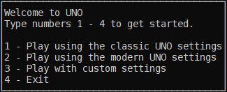

This is where the program begins.
The program will ask for input, prompting for a number from 1 to 4.
- 1 will immediately start a game using the classic UNO game rules. (reccomended)
- 2 will immediately start a game using the modern UNO game rules.
- 3 will bring you to the custom settings menu.
- 4 will exit the program.

Custom settings menu

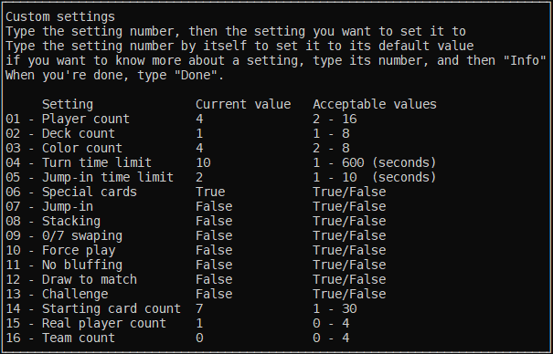
Shown in the picture above are the settings for the classic UNO game rules

This menu appears when you choose the "3" option on the start menu.
This allows you to modify the settings and rules for the game.
Typing "Done" will close this screen and immediately start a game with the chosen settings.

Typing one of the setting numbers shown and then the word "Info" will tell you more about that setting.
Typing one of the setting numbers shown and then a value will set the value for that setting if valid.
Typing one of the setting numbers by itself will set that setting to its default value.

Examples of valid commands:
- 04 20
- 13 info
- 14

Examples of invalid commands:
- 1 10 (You will need to type "01", instead of "1")
- 14 50 (Invalid value. Only numbers 1 to 30 are allowed for setting 14.)

Here are some basic descriptions for what each setting does:
Setting number | Setting name | Acceptable values | Default value | Description
01 | Player count | 2 - 16 | 4 | How many players in total there are.
02 | Deck count | 1 - 8 | 1 | How many sets of cards there will be in the deck.
03 | Color count | 2 - 8 | 4 | How many different colors cards can be.
04 | Turn time limit | 1 - 600 | 10 | How much time in seconds you have to do your turn.
05 | Jump-in time limit | 1 - 10 | 2 | How many seconds you have to jump-in.
06 | Special cards | True/False | True | Whether or not non-number cards will be in the deck. (e.g. +2, skip, reverse)
07 | Jump-in | True/False | False | Whether or not jump-in is enabled. If you have the same exact card as a card that was just played, you can play that card regardless of which player's turn it is.
08 | Stacking | True/False | False | Whether or not stacking is enabled. If you are on the recieving end of a +2 or +4 and have that same card, you can play the card and have the next player draw extra cards instead of having to draw cards yourself.
09 | 0/7 swaping | True/False | False | Whether or not 0/7 swaping is enabled. If someone lays down a 0 card, every body swaps card with the player next to them depending on the turn order. If a 7 card is played, that person can choose to swap cards with anyone of their choosing.
10 | Force play | True/False | False | Whether or not force play is enabled. If you are able to play a card, you are not allowed to take a card from the deck.
11 | No bluffing | True/False | False | Whether or not no bluffing is enabled. If playing a wild or +4 wild card, you are only allowed to choose a color that you have in your hand. If you only have wild or +4 wild cards, you are allowed to select any color.
12 | Draw to match | True/False | False | Whether or not draw to match is enabled. If you have to draw a card, you have to keep drawing cards until you get one that can be played.
13 | Challenge | True/False | False | Whether or not challenging is enabled. If you are on the recieving end of a +4, you can challenge the person that played the card.  If the person could have played any card other than the +4, you win, then both you and the other player will have to draw only half of those cards.  If the person could not have, you lose, and will have to draw extra cards.
14 | Starting card count | 1 - 30 | 7 | How many cards each player will start with.
15 | Real player count | 0 - Player count | 1 | How many of the players are controled by the user. All other players will be computer players. A value of 0 means the game will play itself.
16 | Team count | 0 - Player count | 1 | How many teams there are.

Main interface

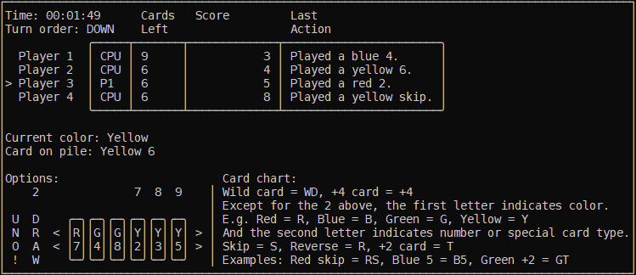
This is the interface you will see throughout the game.

All the way on the top left of the interface, you will see:
- How much time has passed since you started the game
- The turn order
- DOWN means the order goes "player 1, player 2, player 3, etc."
- UP means the order goes "player 3, player 2, player 1, etc."

Below that you will see statistics for each player in the game:
- Whether the player is a real player or computer player
- How many cards they have left in their hand
- How many points they have
- The last action they took

In the middle of the screen you will see:
- The current color players have to match
- The previous card that was played

On the bottom left, you will see the options that you can choose from when it's your turn.
These are the following options that are possible:
- UNO! - This calls UNO for you and/or reports someone forgot to call UNO
- DRAW - Draw a card
- << - See more cards in your hand if possible
- >> - See more cards in your hand if possible
- The options in between the arrows are your cards
If a number appears above the option, it means that you can select it by typing that number and pressing enter.

When viewing cards in your hand, you will notice that the card shows up as two letters.
On the bottom right of the interface you will see a guide on what these mean:
- Wild cards appear as "WD"
- +4 cards appear as "+4"
- Except for wild cards and +4 cards, the first letter indicates color
- The second letter indicates number or card type
- Skip cards have the letter "S"
- Reverse cards have the letter "R"
- +2 cards have the letter "T"
For example:
- A blue 5 shows up as "B5"
- A red skip shows up as "RS"
- A green +2 shows up as "GT"

